NIAGARA FRONTIER TRANSIT METRO SYSTEM, INC.
TRANSPORTATION DEPARTMENT
NOTICE

April 20th, 2020
Form Attached
RE: Commissioner’s Regulations Part 6

TO: ALL CDL Licensed Employees

As stated in the Commissioner’s Regulations part 6 Section 6.21 page 26:

6.21 Notification of an accident or a conviction resulting from a violation of the Vehicle and Traffic or a motor vehicle conviction in another state and license revocation.

- A driver who receives a notice that his or her license, permit or privilege to operate a motor vehicle has been revoked, suspended or withdrawn or who is convicted of a violation of such provisions of this Part as shall constitute a misdemeanor or a felony in any jurisdiction shall notify the motor carrier that employs such person of the contents of the notice before the end of the business day following the day he or she received it. A driver who fails to notify his or her employer of such suspension, revocation or conviction of a violation of such provisions of this Part as shall constitute a misdemeanor or a felony shall be subject to a five (5) working day suspension, or a suspension equivalent to the number of working days such driver was not in compliance with this Part, whichever is longer.

- Any driver who is involved in an accident as defined in Section 6.2 of this Part, or who is convicted of a traffic infraction in any jurisdiction shall notify his or her employer within five (5) working days from the date of conviction or such accident. A driver who fails to notify his or her employer of such conviction or accident within the five (5) working day period shall be subject to a (5) working day suspension. Working day, for the purposes of this section, shall mean any day in which a bus driver is scheduled to work, excluding regularly assigned days off.

Accident shall include any accident with another vehicle, object or person, which occurs in this state or elsewhere, in which any person is killed or injured, or in which damage to the property of any one person, including the operator, in excess of one thousand five hundred dollars is sustained, or in which damage in excess of two thousand five hundred dollars is sustained to any bus.
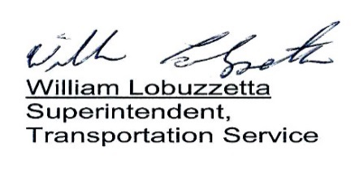
Post: Immediately
Remove: 04/20/21
S:\Trans\Maria\notices\2020\April\19APart6

