NIAGARA FRONTIER TRANSIT METRO SYSTEM, INC.
TRANSPORTATION DEPARTMENT
NOTICE

April 23rd, 2020

RE: Defective Wheelchair Policy

TO: All Operators

Policy
Wheelchair and other mobility devices must be kept in good operating condition. Inadequately maintained equipment can be a hazard for riders and operators.

Procedure
When a customer mobility device becomes disabled while on the vehicle, the operator shall immediately contact the controller and the controller will arrange for a supervisor, transit police or emergency services to provide assistance with transferring the customer off the vehicle at either the customer’s origin or destination. It is the intent of the policy to accommodate the customer’s request for transfer location when possible.

UNDER NO CIRCUMSTANCES SHOULD THE OPERATOR SOLELY ATTEMPT TO OPERATE OR MANEUVER THE MOBILITY DEVICE
When the customer is returned to the point of origin or destination, the Metro Controller will make arrangements and shall confirm the rider will not be stranded. The Operator shall complete a transportation report and the Controller is to record the incident in the bus log. The contact information of the rider (e.g. name, address and phone number) shall be indicated in the bus log and on the transportation report.
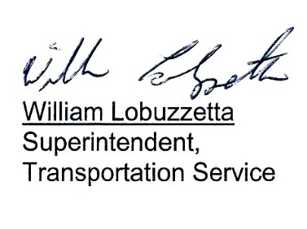
Post: Immediately
Remove: When Notified
S:\Trans\maria\notice\2020\April\DefectiveheelchairPolicy

