Orientation
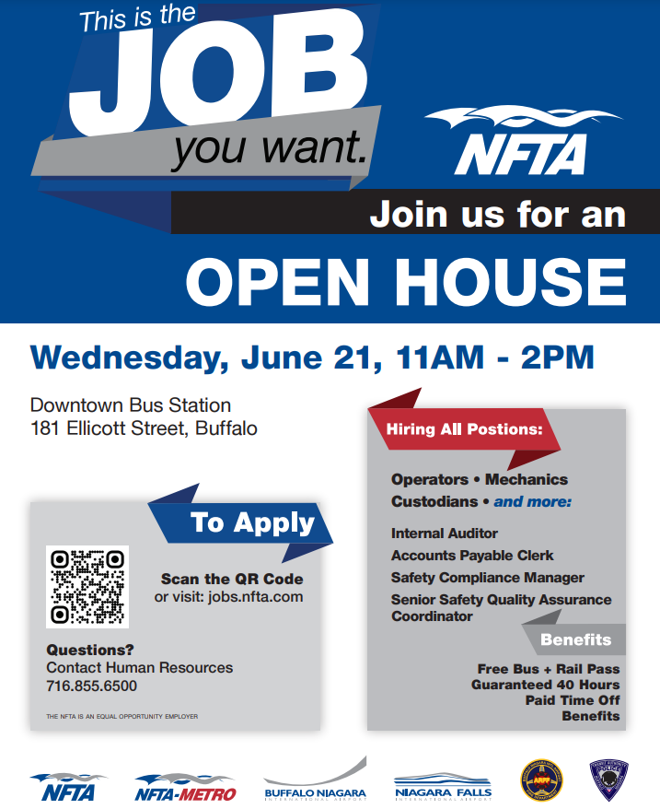

8:05-8:40 Safety (Allison Lenda)

8:45-9:20 EEOC Department (Wafa Dubashi/Sean Fitzpatrick)

Break (10 mins)

9:30-9:40 Transit Police/Building Relationships (Chief Patterson)

9:40-10:50 Medical/Drug & Alcohol Training (Stacy Serba)

Break (10 mins)

11:00-11:10 United Way (Chrissy Cassata-Stayoch)

11:15-12:00 Ethics Training (Legal)

12:00-01:00 Lunch

01:00-02:00 ATU Local 1342 - if applicable (Jeff Richardson)

02:00-02:10 Metro Operations Welcome - if applicable (Rachel Maloney/James Morrell)

02:15-02:30 Badging

02:30-03:15 Benefits Meeting - if applicable (Chris Hart)

03:15-04:00 H.R. Paperwork - if applicable (HR)

