NIAGARA FRONTIER TRANSIT METRO SYSTEM, INC.
TRANSPORTATION DEPARTMENT
NOTICE

April 3rd, 2020

RE: Metropolitan Transportation Center

TO: All Operators

Effective immediately, The Metropolitan Transportation Centers Ellicott Street side door closest to the tower across from the NFTA Police office will be open from 5:30am-12:45am to enter our facility. When exiting the building you can use the North division doors that have crash bars. Please make sure the doors close behind you.
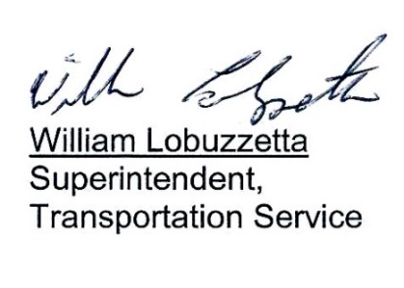

Post: Immediately
Remove: When Notified
S:\Trans\Maria\notice\2020\April\EnteringMTC

