NIAGARA FRONTIER TRANSIT METRO SYSTEM, INC.
TRANSPORTATION DEPARTMENT
NOTICE

April 23rd, 2020

RE Paratransit Employee and Passenger Safety

TO: Paratransit Operators

PAL Operators must at all times protect their own personal safety and the safety of passengers. It is the duty of all employees to be alert and to take the necessary precautions at all times.

Paratransit Operators must NOT:

- Assist clients into or out of buildings
- Lift clients up any stairs
- Lift clients over obstacles
- Lift client’s wheelchair for any kind of adjustments or positions

If the Operators have any concerns or questions regarding the employee or passenger’s safety, contact Control immediately.

PAL Operators must use good judgment, safety and prudence at all times.

Your adherence to this reminder is expected and appreciated.
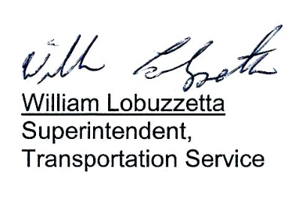

Post: Immediately
Remove: 04-24-21
S:\Trans\Maria\notice\2020\April\PALSafety

