NIAGARA FRONTIER TRANSIT METRO SYSTEM, INC.

TRANSPORTATION DEPARTMENT

NOTICE

April 23rd, 2020

RE: Rule 6.9 Enforcing Regulations

TO: All Operators

Rule 6.9

Metro regulations prohibits anyone from selling, begging, soliciting, smoking, spitting, eating, drinking, using radio/tape players without earphones, or otherwise disturbing other passengers. Operators must use tact in enforcing regulations, and may call the Bus Controller for Police assistance if required.

Your cooperation is expected and appreciated.
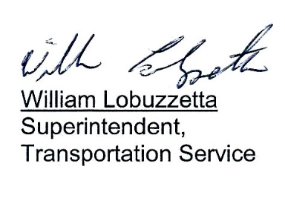

Post: Immediately
Remove: 04-23-21

S:\Trans\Maria\notice\2020\April\Rule6.9

