NIAGARA FRONTIER TRANSIT METRO SYSTEM, INC.
TRANSPORTATION DEPARTMENT
NOTICE

April 23rd, 2020

RE: Americans with Disabilities Act
“Wheelchair Securement”

TO: All Operators

Effective May 10, 2014, Wheelchair Securement:

Under the Americans with Disabilities Act, it is the right of any transit system to require riders using wheelchairs or other mobility devices to be secured.

It is the policy of the NFTA that wheelchair securement is required, thereby creating a safer transport for all riders including those using wheelchairs.

Anyone refusing to have their wheelchair secured will be denied transportation on NFTA Metro Bus & Paratransit vehicles.

All cooperation is expected and appreciated.

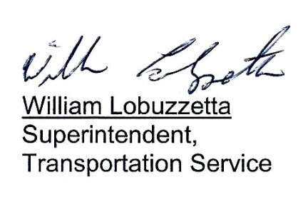

Post: Immediately
Remove: 04-23-21
S:\Trans\maria\notice\2020\April\ADAWheelchairSecurement

