NIAGARA FRONTIER TRANSIT METRO SYSTEM, INC.

TRANSPORTATION DEPARTMENT

NOTICE

April 17th, 2020

RE: Rule 4.21 Service Stops

TO: All Operators

Rule 4.21.2

“Except when a bus is fully loaded or is not in service, Operators must stop at all bus stops, or upon demand in areas where no stops are designed, when prospective passengers are present.”

Your cooperation is expected and appreciated.
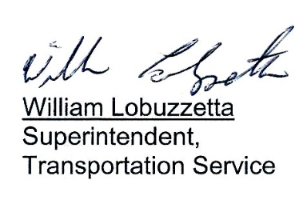

Post: Immediately
Remove: When Notified

S:\Trans\Maria\notice\2020\April\Rule4.21

