NIAGARA FRONTIER TRANSIT METRO SYSTEM, INC.
TRANSPORTATION DEPARTMENT
NOTICE

April 23rd, 2020

RE: Performance Improvement Guidelines

TO: All Operators

In view of Arbitrator Foster’s Award, dated November 5th, 2018, please be advised that effective June 18th, 2019 new PIG 2.2 will become effective.

PIG 2.2 reads…Use of a Mobile Device while operating a motor vehicle (Reference NY CLS 1225 d)

Violations will remain in operators record for 3 years. For purposes of PIG 2.2 “Mobile Device” shall mean…

- Any hand-held mobile telephone, as defined by subdivision one of section twelve hundred twenty-five-c of this article, personal digital assistant (PDA), handheld device with mobile data access, laptop computer, page, broadband personal communication device, two-way messaging device, electronic game, portable computing device or any other electronic device when used to input, write, send, receive or read text for present or future communication.

Please note also that PIG 4.14 shall be amended in view of PIG 2.2 to read “Operating or displaying personal entertainment equipment except during lunch.”

Per Arbitrator Foster’s award, Upon the effective date (6/18/2019) of the new two-step rule, all existing violations under the previous four-step rule (4.14) will be removed from operators’ records.

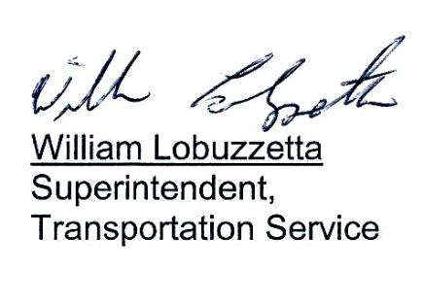

Post: Immediately
Remove: When notified
S:\Trans\Maria\notice\2020\April\PerformanceImprovementGuidelines

