NIAGARA FRONTIER TRANSIT METRO SYSTEM, INC.
TRANSPORTATION DEPARTMENT

NOTICE

April 8th, 2020

RE: Recovery Day

TO: All NFTA Metro Employees

Executive Director, Kim Minkel in collaboration with ATU President Jeff Richardson has granted a recovery day to all NFTA Metro Active Employees. Please see your station supervisor, station clerk or immediate supervisor, to schedule your recovery day. Staffing quotas WILL be in effect. All recovery days must be taken by Monday, June 1st, 2020.

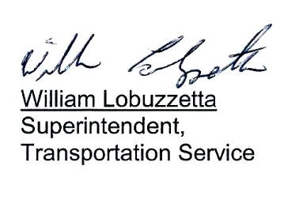

Post: Immediately
Remove: 6-2-20
S:\Trans\Maria\notice\2020\April\RecoveryDay

