NIAGARA FRONTIER TRANSIT METRO SYSTEM, INC.
TRANSPORTATION DEPARTMENT
NOTICE

April 23rd, 2020
RE: Shutting Engines off

TO: All Operators

All operators are required to shut bus engines off when arriving at layovers. Compliance is required by (Rule 4.11) of the current Rule Book. The rule is restated as follows.

  - Engine Operation at Layovers
Operators must shut off the bus engine upon arrival at the
layover point, if the layover will be more than five minutes.
Operators must not restart the engine until immediately
prior to departure, except that if conditions require the
engine may be periodically operated for climate control.

Exceptions are when your vehicle is:

- Stuck in traffic
- Idling for maintenance purposes
- Involved in an emergency situation
- A diesel fueled vehicle operating in an ambient air temperature below 25 degrees for more than 2 hours

OPERATORS MUST NOT KEEP THEIR ENGINES RUNNING UNLESS AN OFFICIAL ALL CALL HAS BEEN MADE BY THE CONTROLLER. The cooperation of ALL OPERATORS is expected to avoid complaints and possible fines regarding this matter.

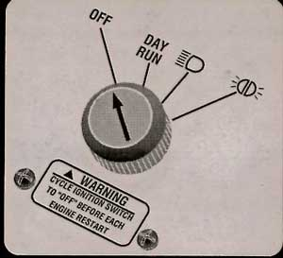 | All Operators:  Upon arriving at any school grounds, Operators are to shut engines off IMMEDIATELY. Set the “Ignition Select switch” to the markers light position, this mode turns on the exterior lights and the destination sign but NOT the ignition.
FOR SCHOOL TRIPPERS

(Do not restart your engine until directed to leave by the school Security)
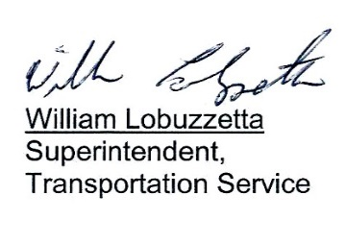
Post: Immediately
Remove: 4-23-2021
S:\Trans\Maria\Notice\2020\April\ShuttingEngineOff

