NIAGARA FRONTIER TRANSIT METRO SYSTEM, INC.
TRANSPORTATION DEPARTMENT
NOTICE

April 24th, 2020

RE: Assisting Paratransit Clients

TO: Paratransit Operators

When performing PARATRANSIT duties, it is a requirement for an Operator to assist any Paratransit client that may request assistance in transporting from their location to their destination. Operators are not obligated, nor responsible to carry, move carts or any bags and belongings, (empty wheelchairs are considered belongings and are NOT to be operated by an Operator).

Operators are responsible in transporting clients to and from the van.

Your adherence to this reminder is expected and appreciated.
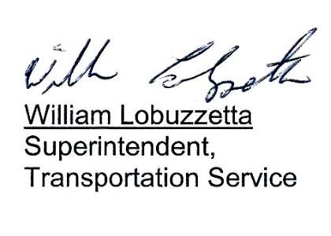

Post: Immediately
Remove: 4/24/21
S:\Trans\maria/notices/2020/April/AssistingPALClients

